Level Three Geography

91429 Demonstrate understanding of a given environment(s) through selection and application of geographic concepts and skills

Resource Booklet
Resource A: Establishing the Mahia Peninsula
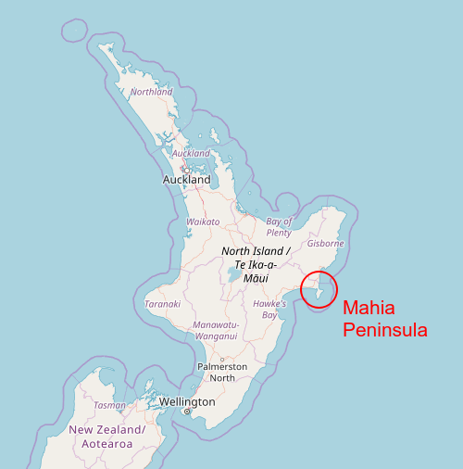

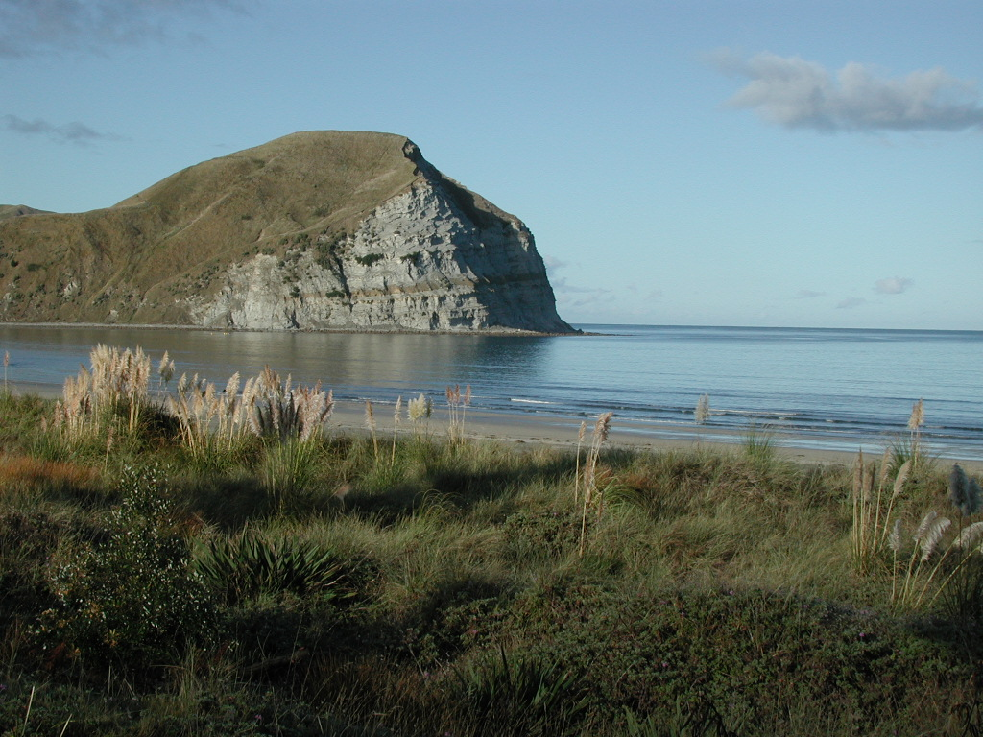
Resource B: Mahia Penisula, topographic map
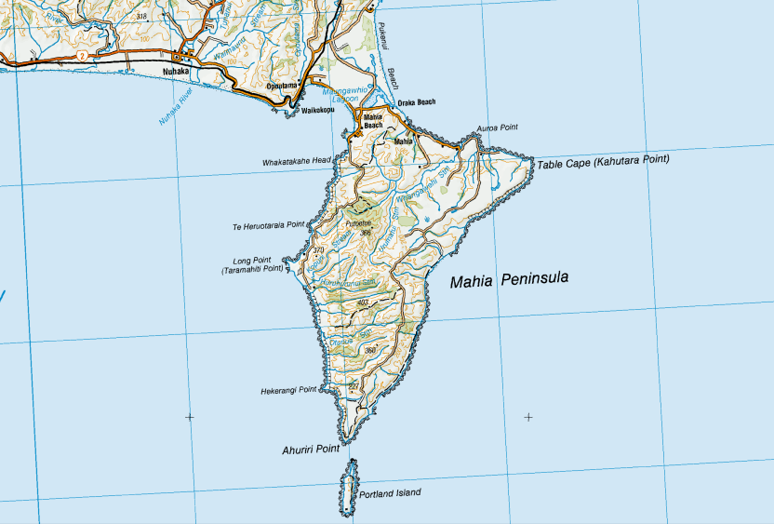
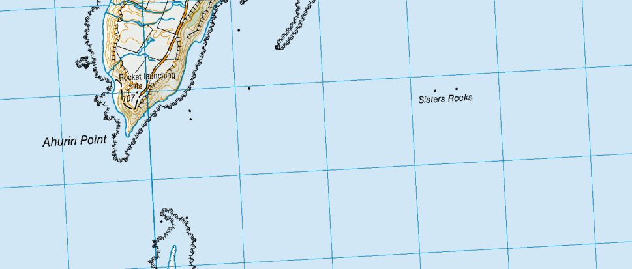
Resource C: Hawke’s Bay Places, Mahia
Large peninsula (21 kms long by 15 kms at widest point) on the northern tip of Hawke Bay, with a 2013 population of 723. Māhia Peninsula (then called Nukutaurua) was an important area of Māori settlement in pre-colonial times. The ancestral canoes Kurahaupō and Tākitimu landed on the peninsula. Māhia Peninsula people claim descent from the 16th-century union of ancestors Rongomaiwahine and Kahungunu. In the 1820s the peninsula became a refuge when Hawke’s Bay was invaded by armed tribes from the west and north.
It still has a significant Māori population – in 2013, 60% of residents identified as Māori. Onenui station, at the southern tip of the peninsula, is owned by Māori.
Ruawharo’s rock
When the Tākitimu landed on Māhia Peninsula the tohunga (priest) Ruawharo decided to settle there. He built a pā above Ōraka Beach and deposited sand from his homeland Hawaiki on a rock to encourage whales to beach there. The rock became one of the most sacred mauri (talismans) in the North Island. The meeting house at Ōpoutama is named after Ruawharo.
The first European settlers were whalers and traders. Early runholders James Watt and George Walker had a 20,000-acre (8,094-hectare) station on the peninsula, which they leased from Māori. The government purchased most of the peninsula in 1864 and the land was farmed thereafter. In the 2000s sheep and beef cattle farming remained an important source of business and employment. Māhia Peninsula and its beaches have become desirable holiday spots.
Māhia and Māhia Beach
Main settlements on Māhia Peninsula. Māhia Beach is on the west side of the isthmus connecting the peninsula to the mainland. Town sections were laid out in 1874 but the township did not grow as envisaged. However, the grid pattern of most streets hint at its planned past.
Māhia is on the east side of the isthmus. The settlement is strung along the coastal road that heads south down the peninsula. Both settlements have a community of permanent residents but also contain a number of baches (holiday homes).
Portland Island
Narrow, 3-kilometre long rectangular island off the southern tip of Māhia Peninsula. Portland Island (or Waikawa) was home to an important whare wānanga (Māori house of learning) called Ngāheru-mai-tawhiti. Whaling stations were established there in the 1840s, followed by pastoral farms in later decades.
A lighthouse was built on the southern end in 1876, and was manned by three keepers who lived on the island, some with families. The lighthouse was automated in 1984 and the old building relocated to Wairoa, where it sits on the banks of the river on the main street. In the 2000s sheep are run on the island by the owners of Oenui station, but it is now uninhabited.

Nūhaka
Small settlement on State Highway 2 north-west of Māhia Peninsula, with a 2013 population of 258. Nūhaka has a general store, fire station and two marae. In 2013, 75.6% of residents identified as Māori.
Mōrere
Site of natural mineral springs on State Highway 2 north of Māhia Peninsula. Mōrere contains a hot springs complex, tea room and camp site. The springs were a traditional bathing spot for the Ngāti Rākaipaaka hapū. In the 1880s most of the surrounding native bush was cleared for farming, except immediately around the springs, which became a thermal reserve in 1895. A bathhouse and hotel were built at this time. The reserve is administered by the Department of Conservation and the hot springs are leased to a private operator.
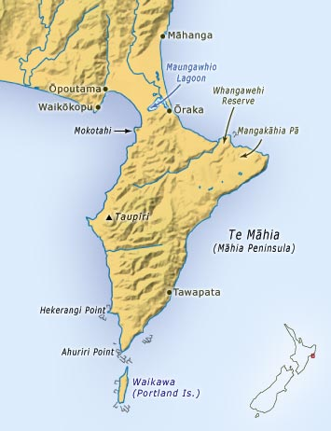
Resource D: Statistics
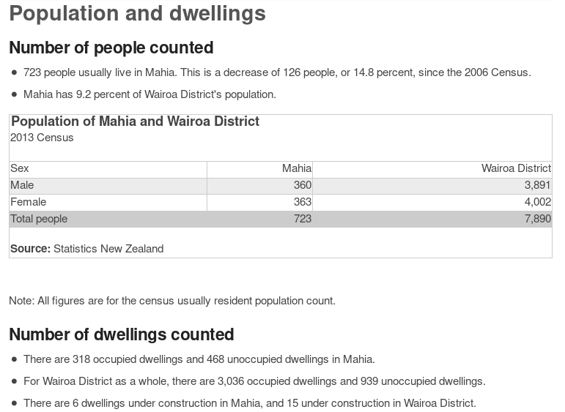
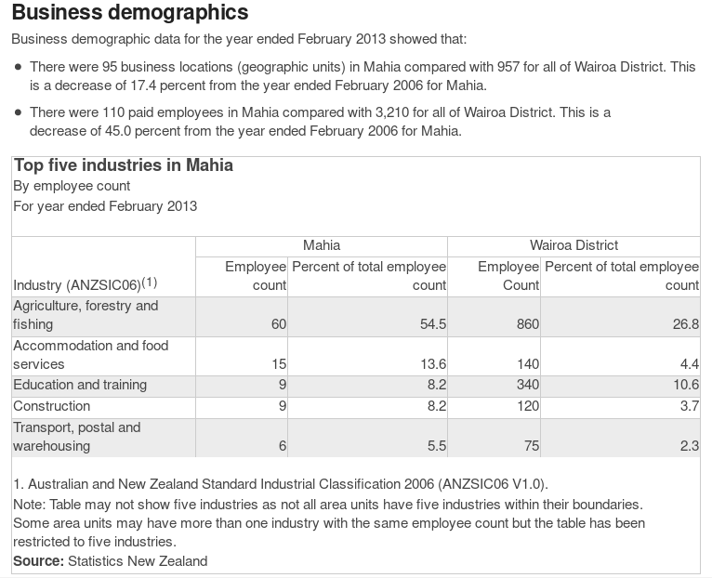
Resource E: Rocket Lab delivers nanosatellites to orbit on first successful test launch
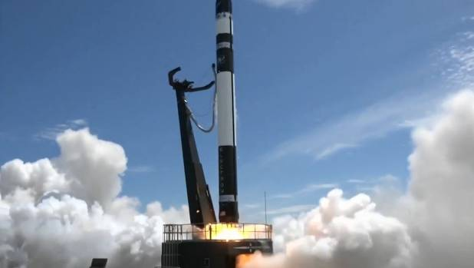
The first rocket successfully launched from New Zealand is now tucked into orbit hundreds of kilometres above Earth. The unmanned Electron rocket, named 'Still Testing', took off from Māhia Peninsula at 2.45pm on Sunday. Cheers and clapping erupted throughout Rocket Lab's Auckland mission control as it successfully reached orbit about 2.53pm.
The rocket lifted off from its launch pad on Sunday.
A live stream video of the launch featured magnificent imagery of New Zealand as the 17-metre-long rocket powered away from earth through the atmosphere.
"Today represents a significant milestone in opening up access to space, to better understand our planet and improve life on Earth," Rocket Lab said.
Richard Easther, a professor of physics at the University of Auckland, said the launch represented a "red-letter day for New Zealand".
"To put this into perspective, we are now one of just a dozen countries to have successfully built and deployed a rocket that can put satellites into orbit," Easther said.
The other nations are either world powers such as the USA and Russia, or smaller countries "which are armed to the teeth" such as Israel and North Korea.
Easther said that meant "New Zealand really stands alone with a technically advanced, commercially focussed launch vehicle". He added it was "just the first chapter in what promises to be a fascinating story for the country and our technology and science sectors".
Economic development minister David Parker congratulated Rocket Lab on the successful launch, and said New Zealand was well positioned to support further development of the space industry. "Our natural advantage of clear skies and seas, and relatively low levels of air traffic make us an attractive location for space activity." Parker said.
Parker visited Mission Control to watch the countdown on Saturday, and pledged further support for the space industry.
"The Government is particularly interested in advancing areas where New Zealand has existing strengths in space-based data applied to agri-technology, hazard management, oceanography and meteorology," he said.
'Still Testing' carried three satellites into space from New Zealand. One of the satellites will take images of Earth for United States company Planet Labs. The other two will capture weather and ship tracking data for Spire Global. This was the second rocket to be launched by the New Zealand aerospace company, but the first to make it into orbit.
Six attempts made by Rocket Lab to launch on Saturday failed and attempts were scrubbed altogether by early evening. Strong wind high in the atmosphere, a power fault, and too much liquid oxygen feeding into the rocket's engine obstructed multiple launch attempts.
Rocket Lab plans to hold three test rocket launches before it operates commercially to carry satellites into orbit frequently, at a cost significantly lower than its competitors.
Resource F: Species Restoration Plan for the Whangawehi Catchment Area, Mahia Peninsula, Hawke’s Bay
This plan describes a brief overview of the native wildlife restoration possibilities for the Whangawehi Catchment, a 3588ha area situated on Mahia Peninsula in northern Hawke’s Bay. Predator control and habitat enhancement programmes have been underway since 2011, beginning the process of creating conditions that will be favourable for wildlife to return and once again flourish.
The numerous pockets of mature remnant forest, streams, wetlands and the extensive coastal influence make the area suitable for the restoration of a wide range of forest birds, shorebirds, seabirds, reptiles and invertebrates.
As predator numbers are reduced and the habitat improves some bird species still present locally will recover on their own, other species may naturally recolonise the area with time, while others will need to be reintroduced. It is those species that will need the WCMG’s help to return which this plan focusses on.
The WCMG has operated a mustelid trapping programme for over a year around the wetland and riparian areas along the Whangawehi stream. As this trapping programme is expanded and rodent control is implemented throughout the catchment, the area will be suitable for establishing populations of robin, tomtit, whitehead and rifleman. Pateke (brown teal) and kiwi could also be considered once a landscape scale ‘top-predator’ control programme throughout the catchment is implemented.
In the longer term other reintroduction programmes could be considered for species such kakariki, kaka, a variety of seabirds and reptiles.

Resource G: Mahia Peninsula
The Mahia Peninsula is a hilly promontory projecting south into the sea, between Poverty Bay and Hawke’s Bay. According to Maori legend, Mahia Peninsula is Te matau a Maui - the fish-hook of Maui.
The peninsula has a number of beautiful beaches and peaceful holiday villages and is a natural playground for people who like to surf, fish, dive, kayak and swim. It has an interesting mix of sandy and rocky beaches – some exposed to the ocean swells, others beautifully sheltered.
Discover the black sand of Black’s Beach and the tranquillity of Poutama and Mahia Beaches. If you want to catch some waves, Mahanga Beach and The Reefs are great destinations.
Make time for a walk in the Mahia Peninsula Scenic Reserve, one of the largest areas of lowland coastal forest in Eastland. This 374 hectare (935 acre) reserve is one of the last large tracts of lowland coastal forest remaining on the North Island’s east coast. A 3.5 kilometre track takes walkers through a range of different types of native vegetation – tawa, kohekohe, rewarewa, karaka, rimu, matai and kahikatea. You need to allow about two hours to complete the loop. The track is steep in places, but you can enjoy a rest in the picnic area which is nestled amongst stands of nikau, rimu and rewarewa - a lovely way to escape the sun for a couple of hours.
A special place of interest on the eastern side of the peninsula is Piko O Te Rangi, or Coronation Reserve. Within the reserve is a rock with a naturally formed basin. In early settlement times, it was used as a font when Maori were baptised into the Christian faith by Bishop William Williams. A hole in the wall of rocks nearby is believed to have been used to store bibles.
Resource H: East Cape Region
The East Cape region derives its name from the cape at the north-eastern end of the North Island. The region is divided by the Raukumara Range and, while there are close similarities between the western and the eastern sides of the region, it is customary to include the western part with the Bay of Plenty. Hence the limits of the region are defined by the extent of the five counties: Matakaoa, Waiapu, Uawa, Waikohu, and Cook, which, together with their interior boroughs, constitute the principal basis for the collection of statistics. Gisborne (urban area population, 1961, 25,065) is the only town in the region and in 1961 it had a total population of 43,653 (1.80 per cent of the national total) of which 31.02 per cent were Maoris.
The East Cape has the reputation of including that part of New Zealand upon which Captain Cook first set foot and it was one of the regions where the impact of European civilisation was first felt with the introduction of Christianity and, later, with the settlement of Europeans (1831). But in New Zealand's history early prominence has never been a condition of ultimate importance and, in the second half of the twentieth century, the East Cape is probably the most isolated and one of the least known regions of the North Island; and though the statement must be treated with some caution, the region is socially the most problematical of all. For the area is pre-eminently a farming district, with very little industry and few alternative avenues of economic development. It has, however, a large and rapidly growing Maori population requiring in the immediate future increased opportunities for employment. The East Cape offers the social scientist a remarkable field of research; for its Maori community, having experienced the shock of a new culture, is in the process of adjusting itself to modern civilisation in a largely agricultural economy where population growth is rapid.
Resource I: Mahia Beach
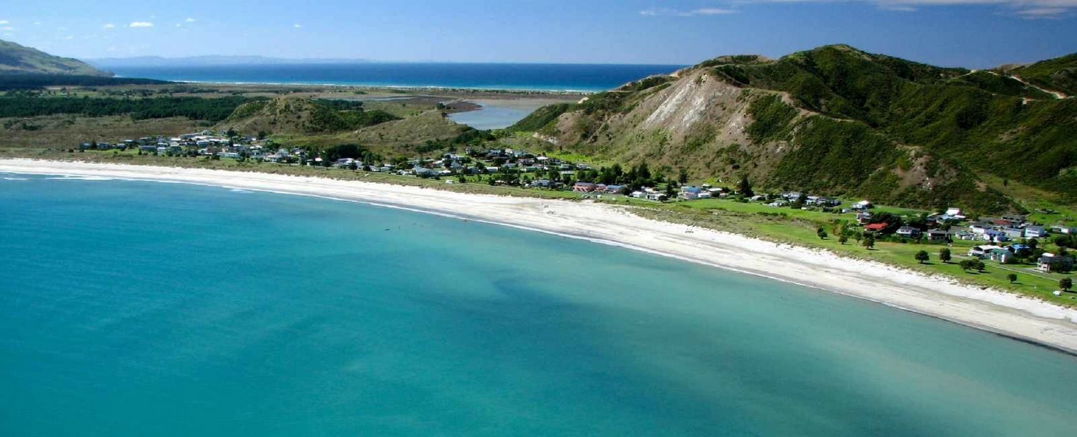
Resource J: Moko the Dolphin
Moko (2006 – 7 July 2010) was a male bottlenose dolphin who associated with humans on the east coast of the North Island of New Zealand from 2007 to 2010.
Moko, short for Mokotahi, a headland on Mahia Peninsula, was three-years-old as of July 2009. He resided at Mahia Beach for two and a half years from 2007 to September 2009, and became a major attraction there. He received worldwide fame when he rescued two pygmy sperm whales in March 2008. A year later, he trapped a woman out at sea. At the beginning of September 2009 Moko moved 80 km up the coast to Waikanae Beach, Gisborne, and in January 2010 he moved to Whakatane in the Bay of Plenty for five months before following a fishing boat to Tauranga on 3 June. Scientists were worried about Moko's welfare after a study found he had been scarred by boats and a fish hook. He was found dead on a beach at Matakana Island near Tauranga on 7 July 2010.
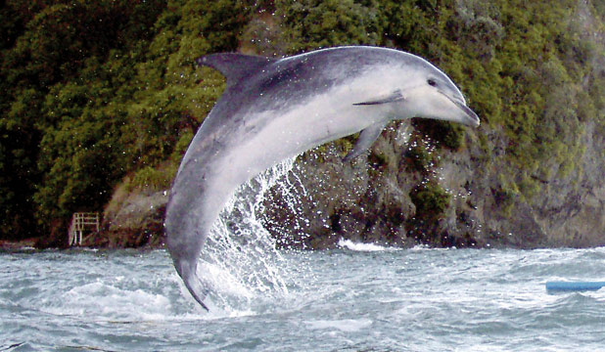
SOURCES
- Resource A: openstreetmap, http://www.datuopinion.com/peninsula-mahia
- Resource B: LINZ
- Resource C: Te Ara
- Resource D: Statistics New Zealand
- Resource E: https://www.stuff.co.nz/business/100757521/rocket-lab-launches-electron-test-rocket-from-mhia-peninsula-hawkes-bay
- Resource F: https://whangawehi.files.wordpress.com/2017/11/species-restoration-plan-for-the-whangawehi-catchment-area-oct-25.pdf
- Resource G: https://www.newzealand.com/ie/feature/mahia-peninsula/
- Resource H: https://teara.govt.nz/en/1966/east-cape-region
- Resource I: https://www.hawkesbaynz.com/assets/HBT-See-and-Do/Beaches/HBT-Beaches-MahiaBeach-1600x650.jpg
- Resource J: https://en.wikipedia.org/wiki/Moko_(dolphin), http://static2.stuff.co.nz/1374541376/227/8953227.jpg

